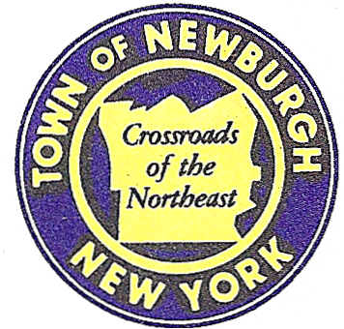

TOWN OF NEWBURGH
_______Crossroads of the Northeast __________________________
OLD TOWN HALL
308 GARDNERTOWN ROAD NEWBURGH, NEW YORK 12550

PLANNING BOARD
JOHN P. EWASUTYN, CHAIRMAN
TELEPHONE 845-564-7804
FAX 845-564-7802
E-MAIL: planningboard@townofnewburgh.org

PLANNING BOARD AGENDA

February 16th, 2017

*PLEASE NOTE: The Planning Board Meeting will start at 7:00 P.M. and all Applicants/Representatives
are to be present at that time. The Meeting will be held in the Meeting Room of Town Hall,
located at 1496 Route 300, Newburgh NY.*

1. Lands of Costubbs, LLC-Clearing Permit (17-02) PUBLIC HEARING
2 Lakeside Road CLEARING GRADE
Section 86, Block 1, Lot 39.3
Zone: IB
Rep: Vincent J. Doce, Associates
242 South Plank Road
Newburgh, NY 12550

2. Amer, Duch, Dellamarco & Petrosky Lot Line Change (17-06) INITIAL APPEARANCE
Kathleen Heights & Frozen Ridge Road
Section 20, Block 1, Lot 134,14.1 &14.21
Zone: R2
Rep: Jonathan N. Millen, Automated Construction Enhanced Solutions, Inc.
196 Sara Lane, Ste. 102
Newburgh, NY 12550

3. CVS (15-23) AMMENDED SITE PLAN
Corel Place (Route 52)
Section 60, Block 3, Lot 5.2
Zone: B
Rep: Cuddy & Feder LLP
300 Westage Business Center, Suite 380
Fishkill, NY 12524

*WORK SESSION*
Project Readiness Discussion scheduled for 5:30 p.m. in the Meeting Room of
Town Hall on Thursday, February 16th, 2017.*

4. RAM Hotels, Inc. (16-21) COMMERCIAL SITE PLAN
Unity Place
Section 97, Block 2, Lot 37
Zone: IB
Rep: Mecurio-Norton-Tarolli- Marshall
45 Main St. PO Box 166
Pine Bush, NY 12566

5. NPA Site Plan (17-03) COMMERCIAL SITE PLAN
NYS Route 747 Blvd.
Section 89, Block 1, Lot 80.2 & 80.1
Zone: IB
Rep: Zen Design Consultant, Inc.
6 Old North Plank Road
Newburgh, NY 12550

PLANNING BOARD BUSINESS
WORK SESSION

1. Longview Farm/Summer Kim (2006-39) 6 mos. Extension from February 16, 2017 to July
16, 2017.

*WORK SESSION*
Project Readiness Discussion scheduled for 5:30 p.m. in the Meeting Room of
Town Hall on Thursday, February 16th, 2017.*

